1. Explain the purpose of the DataType attribute.

We only want the Date to be displayed so we made a DataType attribute that is more specific then the database intrinsic type

1. Describe the relationship between the DataType attribute and HTML5.

The DataType attribute emits HTML 5 data- (pronounced data dash) attributes that HTML 5 browsers consume. The DataType attributes don't provide validation.

1. The DisplayFormat attribute can be used by itself without the DataType attribute, but what is the advantage of using DataType?

The browser can enable HTML5 features. For example, show a calendar control, the locale-appropriate currency symbol, email links, client-side input validation, etc. By default, the browser renders data using the correct format based on the locale.

1. Do a screen print of the Student page showing the revision of the enrollment date field.

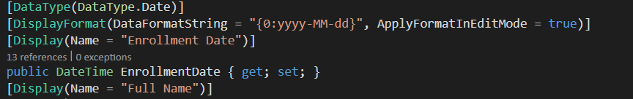

1. Do a screen print of the Create Student page demonstrating the editing capabilities of the StringLength and RegularExpression attributes applied to the first and last name fields.

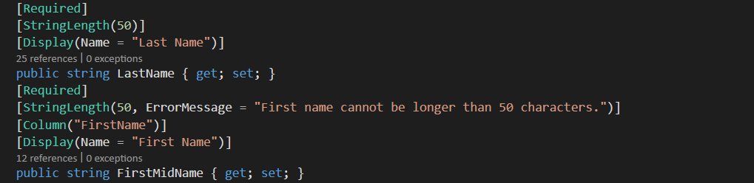

1. What attribute is used to change the model field name to a different name in the database?

TypeName

1. What must you remember to do when you change the model?

Change the database by migrating the new model

1. Do a screen print from SSOX showing the new table design after migrations.

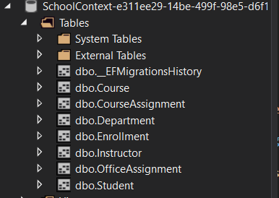

1. When is the Required attribute not needed?

When the data as an no-nullable type of data like DateTime, int, and double.

1. Assuming a field is required, what’s an alternative to using the Required attribute?

Allow Null

1. In the case of a one-to-many relationship in the schema (student having more than one course, for example), how does entity framework handle it in code?

Unlike a many-to-many relationship you don’t need a join table.

1. When must the Key attribute be used?

Each table has to have a key.

1. True or False: Entity Framework automatically creates foreign keys.

True

1. What is the code to override the default action of cascade delete for the Department/Instructor relationship?

modelBuilder.Entity<Department>()

.HasOne(d => d.Administrator)

.WithMany()

.OnDelete(DeleteBehavior.Restrict)

1. Briefly describe the term FluentAPI.

It is used for DB mapping. In Fluent API there are no attributes, so the entity class is very clean. Most devs use Attributes and fluent API in a mix

1. Use the EF Power Tools to create the finished ERD, and do a screen print.

I couldn’t get EF Power Tool to install properly so this is what it is support to look like

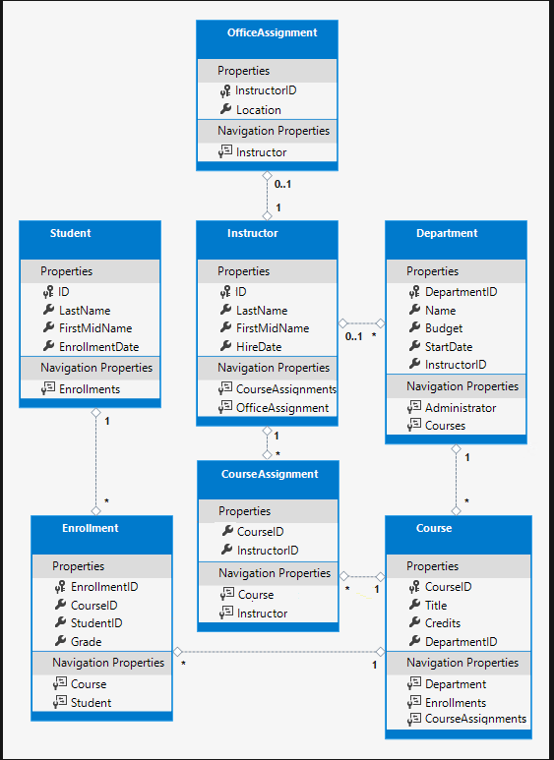

1. Use the migrations feature to seed the new database. Do a screen print of the new code that was added to do this.

We seeded a lot of new information in this step so here is just some of it

